**MODULE 3**

**1. What are the four important <Meta>tags we use in SEO?**

ANSWER 1

There are four Meta tags which are available are:

1. Meta Title tags
2. Meta description tags
3. Meta keywords
4. Meta Robot tag

**2. What is the use of open-graph tags in a website?**

ANSWER 2

Open Graph is an internet protocol that was originally created by Face book to standardize the use of metadata within a webpage to represent the content of a page. Within it, you can provide details as simple as the title of a page or as specific as the duration of a video.

**3. What tag we will use to add an image to the website? Explain the points we should care**

About while adding the image to the website.

ANSWER 3

We use <img> tag to add image to the website.

Images are a best addition to any website. They help break up the text on your site and give lead a visual example of things you mention on your page. These images are a great opportunity for your business to really engage your users.

**4. What is the difference between NOFOLLOW and NOINDEX?**

ANSWER 4

Nofollow tag : This tag instructs the crawler not to follow the links on the page.

Noindex tag: This tag is used to instruct the search engine crawler not to index the page.

**5. Explain the types of queries.**

ANSWER 5

**Transactional Queries**:

If the user want to do something like buy a phone. If you are selling phone and you have pricing of phones with reviews then the user can look at the prices, user reviews and then he can buy the phone

**Informational Queries**:

Where the user is looking for information. How can you effectively service these queries say you have a hotel in Switzerland your site has month wise weather in Switzerland it would enable the user to visit your page get an answer from there he can also look at your hotel property and potentially book it for his next vacation.

**Navigation Queries:**

Search of a certain Product/ Service – when a user is specifically looking for a product by brand—example would be you searching for Facebook.com on Google and clicking on the results.

**6. What is the importance of Site Map and Robot.txt in SEO?**

ANSWER 6

A sitemap tells Google which pages and files you think are important in your site, and also provides valuable information about these files.

A robots.txt file tells search engine crawlers which URLs the crawler can access on your site. This is used mainly to avoid overloading your site with requests.

**7. Below is the list of pages for an e-commerce site that doesn’t need to be crawled by any**

**Crawler**

**-Admin pages**

**-cart page**

**-Thank you page**

**-Images**

ANSWER 7

SKIPPED

**8. What are on-page and off-page optimization?**

ANSWER 8

On-page optimization in SEO is the all the things we do on our website which help boost ranking.

It means to optimize your website and make some changes in the title, Meta tags, structure, robots.txt, etc.Most on-page SEO strategies focus around one topic that is user experience. Better user experiences= more conversions. Off-page optimization takes place outside the page. There are several off pages SEO techniques used to improve page rank in the search engine results page. It means optimizing your websites through backlinks, social media promotion, blog submission, press releases submission, etc.

**9. Perform an on-page SEO using available tools for https://vidisha111.blogspot.com/2022/06/always-think-positive.html**

ANSWER 9

We create backlink to see below:

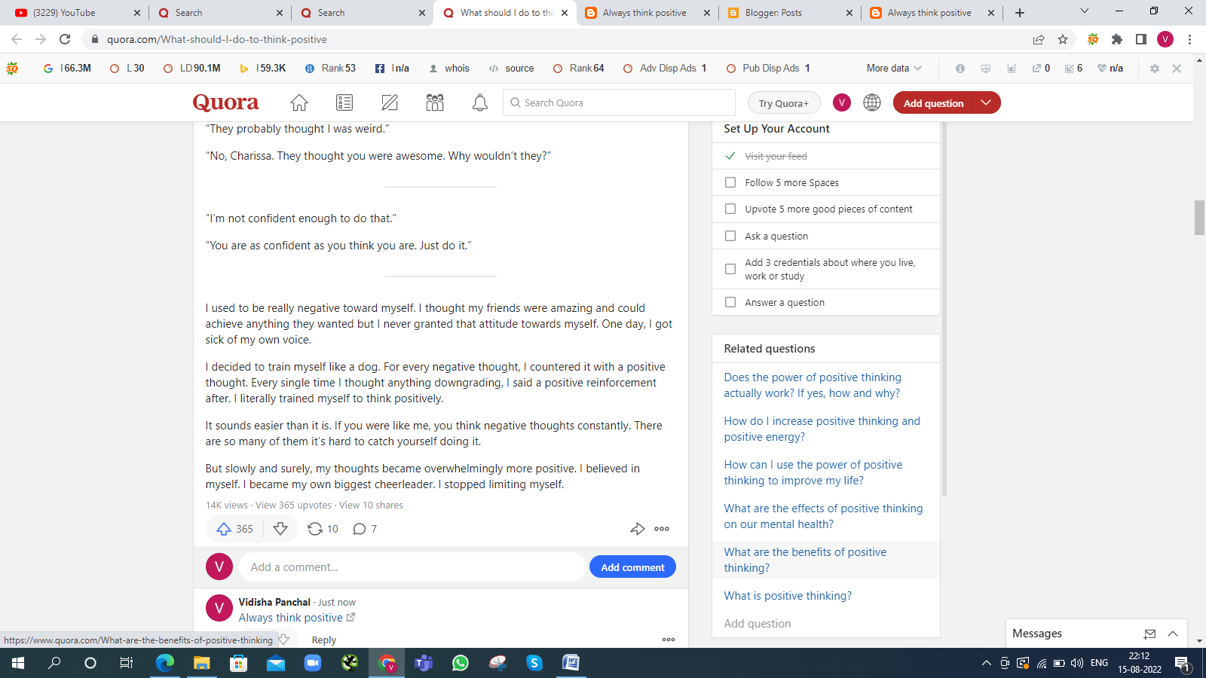

**10. Prapare complete on-page and off-page SEO audit report for**  <https://learnmicrosoftword2007.blogspot.com/>

<https://vidishaevent.blogspot.com/>

ANSWER 10 Prepare the Audit Report of on-page and off-page SEO is below:

<https://analytics.google.com/analytics/web/#/p325280582/reports/explorer?params=_u..nav%3Dmaui&r=top-events&rui>

**11.What are the characteristics of “bad links”?**

ANSWER 11

Characteristic of Bad Links are:

--It’s On Low- Authority Or Questionable Domain

--It’s Pointing To A Source Irrlevant To Its Content

-- It’s Repeated Too Many Times On The Domain

--It’s Embedded In Suspiciously Keyword-Matched Anchor Text

-- It’s Isolated From Any Meaningful Content

**12. Perform Keyword Research then create a blog on “Importance of IT Training” and provide a link to**

**TOPS Technologies and connect it with the webmaster and Google Analytics**

ANSWER 12

We created Blog on ”Importance of IT Traning “ and link is below:

<https://learnmicrosoftword2007.blogspot.com/2022/08/importance-of-it-training.html>

and We find some keyword related to my blog as under:

**Low** **Medium**

IT classes IT course online

IT classes near me IT training courses

It training programs best it courses

It certification courses

**13.What is the use of Local SEO?**

ANSWER 13

Local SEO is a search engine optimization strategy that helps your business be more visible in local search results on Google. Any business that has a physical location or serves a geographic area can benefit from local SEO.